Experiment 1: Image Classification

Problem Statement
A deep learning model processes a grayscale image represented as a matrix. Explain how matrix flattening, vector operations and matrix multiplication calculate the output of a fully connected layer.

Theory
A grayscale image of size m × n is a matrix of pixel intensities (0 to 255). A fully connected layer expects a one-dimensional input, so the image goes through three steps:
- Flattening: the m × n matrix is reshaped into a vector x of length m·n (a 4 × 4 image becomes a 16 × 1 vector). Pixels are first divided by 255 so values lie in [0, 1].
- Vector operation (dot product): each neuron i holds a weight vector wᵢ. Its pre-activation is the dot product of wᵢ with x plus a bias: zᵢ = wᵢ · x + bᵢ.
- Matrix multiplication: stacking the weight vectors of all k neurons as rows gives a weight matrix W of shape k × (m·n). One multiplication computes every neuron at once:
z = W x + b a = f(z)
Here W is (k × mn), x is (mn × 1), b is (k × 1), so z is (k × 1). The activation f (ReLU, softmax) then produces the layer output; softmax converts the scores into class probabilities.

Algorithm
- Define the 4 × 4 image matrix and normalise it.
- Flatten it to a 16-element vector x.
- Initialise W (3 × 16) and b (3) for a 3-neuron layer.
- Compute z = Wx + b and verify neuron 1 using np.dot.
- Apply ReLU and softmax, then take argmax as the predicted class.

Program
import numpy as np
np.set_printoptions(precision=3, suppress=True, linewidth=100)
np.random.seed(1)

# 4x4 grayscale image (pixel values 0-255)
img = np.array([[ 0, 50, 100, 150],
[ 30, 80, 130, 180],
[ 60, 110, 160, 210],
[ 90, 140, 190, 255]])
print("Image matrix (4x4):\n", img)
print("Shape:", img.shape)

# Step 1: normalise and flatten (4x4 -> 16x1 vector)
x = (img / 255.0).flatten()
print("\nFlattened + normalised vector x, shape:", x.shape)
print(x)

# Step 2: weights (3 neurons x 16 inputs) and bias (3)
W = np.random.randn(3, 16) * 0.3
b = np.array([0.1, -0.2, 0.05])
print("\nWeight matrix W shape:", W.shape, "| Bias b shape:", b.shape)

# Step 3: matrix-vector multiplication + bias (z = Wx + b)
z = W @ x + b
print("\nz = W.x + b ->", z)

# Verify neuron 1 using an explicit vector dot product
z1_manual = np.dot(W[0], x) + b[0]
print("Neuron-1 manual dot product:", round(z1_manual, 3), "| matches matrix result:", np.isclose(z1_manual, z[0]))

# Step 4: activation (ReLU) and softmax for class probabilities
a = np.maximum(0, z)
print("\nReLU output a =", a)
p = np.exp(z - z.max()); p = p / p.sum()
print("Softmax probabilities =", p, "| sum =", round(p.sum(), 3))
print("Predicted class:", int(np.argmax(p)))

Output
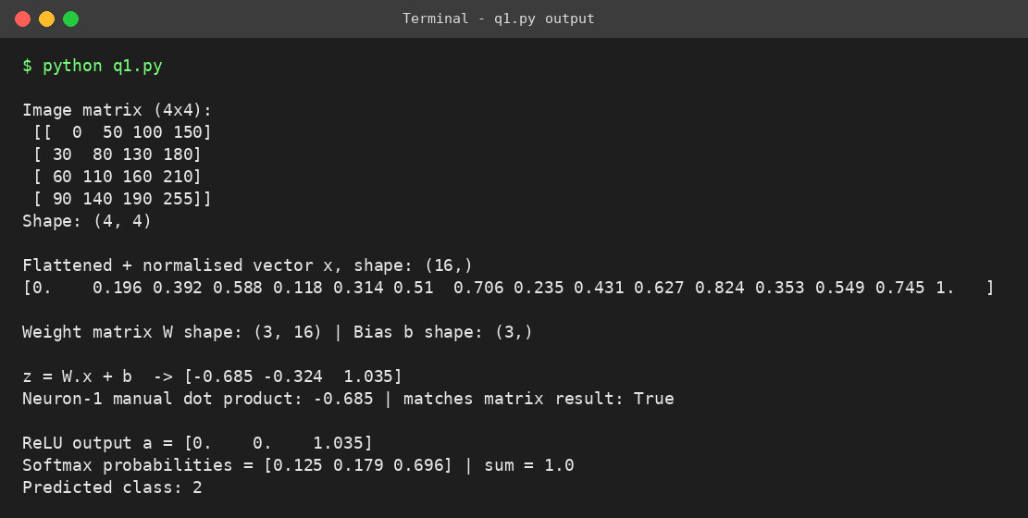
Fig. 1: Output screen of Program 1

Result
The 4 × 4 image was flattened to a 16-element vector and multiplied with a 3 × 16 weight matrix. The manual dot product for neuron 1 matched the matrix result, confirming that matrix multiplication is simply many dot products computed together. The layer predicted class 2 with probability 0.696.

Experiment 2: Student Performance Prediction

Problem Statement
A neural network predicts student performance from attendance, assignment scores and internal marks. For a feature matrix of 100 students and 3 features, explain how matrix multiplication with a weight matrix and addition of a bias vector produce the predicted outputs.

Theory
The 100 students are stacked as rows of a feature matrix X of shape 100 × 3 (columns: attendance, assignment score, internal marks). The weights form a matrix W of shape 3 × 1, and the bias is a single value b.
Y = X W + b
- Matrix multiplication: (100 × 3)·(3 × 1) gives a 100 × 1 matrix. Each entry is the weighted sum w₁·attendance + w₂·assignment + w₃·internal for one student, so all 100 predictions are computed in a single operation.
- Bias addition: the bias shifts every prediction by a constant. It is added to each of the 100 rows through broadcasting, so it needs no explicit loop.
- Weights: a larger weight means that feature influences the predicted score more. Here internal marks carry the highest weight (0.45).
If a layer has k output neurons, W becomes 3 × k, b becomes a vector of length k, and Y becomes 100 × k.

Algorithm
- Create X (100 × 3) with attendance, assignment and internal marks.
- Define W (3 × 1) and bias b.
- Compute Y = X @ W + b.
- Verify student 1 manually and summarise the predictions.

Program
import numpy as np
np.set_printoptions(precision=2, suppress=True, linewidth=100)
np.random.seed(7)

# Feature matrix X: 100 students x 3 features
# columns: attendance(%), assignment score(/100), internal marks(/100)
X = np.column_stack([np.random.uniform(60, 100, 100),
np.random.uniform(40, 100, 100),
np.random.uniform(35, 100, 100)])
print("X shape (students x features):", X.shape)
print("First 5 students:\n", X[:5])

# Weight matrix W (3 features x 1 output) and bias b
W = np.array([[0.20], [0.30], [0.45]])
b = np.array([5.0])
print("\nW shape:", W.shape, "| b shape:", b.shape)

# Forward pass: Y = XW + b (bias is broadcast to all 100 rows)
Y = X @ W + b
print("\nY = XW + b, shape:", Y.shape)
print("Predicted performance of first 5 students:\n", Y[:5])

# Manual check for student 1
s1 = 0.20*X[0,0] + 0.30*X[0,1] + 0.45*X[0,2] + 5.0
print("\nStudent-1 manual calculation:", round(s1, 2), "| matches:", np.isclose(s1, Y[0,0]))

print("\nMean predicted score: %.2f Max: %.2f Min: %.2f" % (Y.mean(), Y.max(), Y.min()))
print("Students predicted 'at risk' (< 60):", int((Y < 60).sum()))

Output
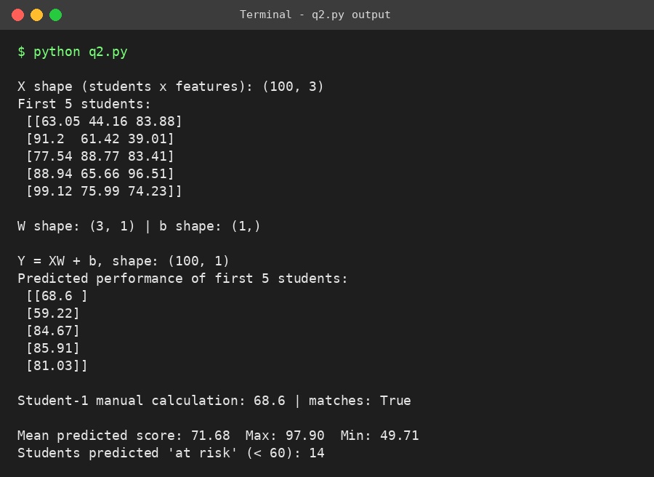
Fig. 2: Output screen of Program 2

Result
The 100 × 3 feature matrix was multiplied by the 3 × 1 weight matrix and the bias was broadcast, producing a 100 × 1 vector of predicted scores. The manual calculation for student 1 (68.60) matched the matrix output, and 14 students were flagged as at risk (predicted score below 60).

Experiment 3: E-commerce Recommendation System

Problem Statement
An online platform represents 500 products with 20 numerical features each. Explain how vector dot products and matrix multiplication calculate similarity scores and recommend relevant products.

Theory
The products form a matrix P of shape 500 × 20, where each row is one product's feature vector.
- Dot product: for two products a and b, a · b = Σ aᵢbᵢ. It is large when both vectors have high values in the same features.
- Cosine similarity: dividing by the vector lengths removes the effect of magnitude: cos(a, b) = (a · b) / (‖a‖ ‖b‖). If rows are normalised to unit length first, the plain dot product equals cosine similarity.
- Matrix multiplication: with normalised rows Pₙ, the product S = Pₙ Pₙᵀ is a 500 × 500 matrix whose entry S[i][j] is the similarity of product i and product j. All pairs are scored in one operation.
- Recommendation: sort row i of S in descending order (ignoring product i itself) and recommend the top-N products. For a customer, average the vectors of liked products into a profile u and compute scores = Pₙ u.
S = Pₙ · Pₙᵀ (500 × 500) scores = Pₙ · u (500 × 1)

Algorithm
- Create the 500 × 20 product matrix P.
- Normalise each row to unit length.
- Compute the similarity matrix S = Pₙ @ Pₙᵀ.
- Pick the top-5 largest values in the row of the viewed product.
- Build a customer profile from liked products and score all products.

Program
import numpy as np
np.set_printoptions(precision=3, suppress=True, linewidth=100)
np.random.seed(3)

# 500 products x 20 features
P = np.random.rand(500, 20)
print("Product matrix P shape:", P.shape)

# Dot product between two products
d = np.dot(P[0], P[1])
print("\nDot product of product 0 and 1: %.3f" % d)

# Normalise rows to unit length -> dot product becomes cosine similarity
Pn = P / np.linalg.norm(P, axis=1, keepdims=True)
cos01 = np.dot(Pn[0], Pn[1])
print("Cosine similarity of product 0 and 1: %.3f" % cos01)

# Matrix multiplication gives ALL pairwise similarities at once
S = Pn @ Pn.T
print("\nSimilarity matrix S = Pn.Pn^T shape:", S.shape)
print("Diagonal (self-similarity) first 3:", np.diag(S)[:3])

# Recommend top-5 products similar to product 10
item = 10
scores = S[item].copy(); scores[item] = -1
top5 = np.argsort(scores)[::-1][:5]
print("\nTop-5 recommendations for customer who viewed product", item)
for r, i in enumerate(top5, 1):
print(" %d. Product %3d similarity = %.3f" % (r, i, S[item, i]))

# Customer profile = average of liked products, scored against all products
liked = [10, 25, 77]
u = Pn[liked].mean(axis=0)
user_scores = Pn @ u
user_scores[liked] = -1
rec = np.argsort(user_scores)[::-1][:5]
print("\nCustomer liked products", liked)
print("Recommended products:", rec)
print("Scores:", user_scores[rec])

Output
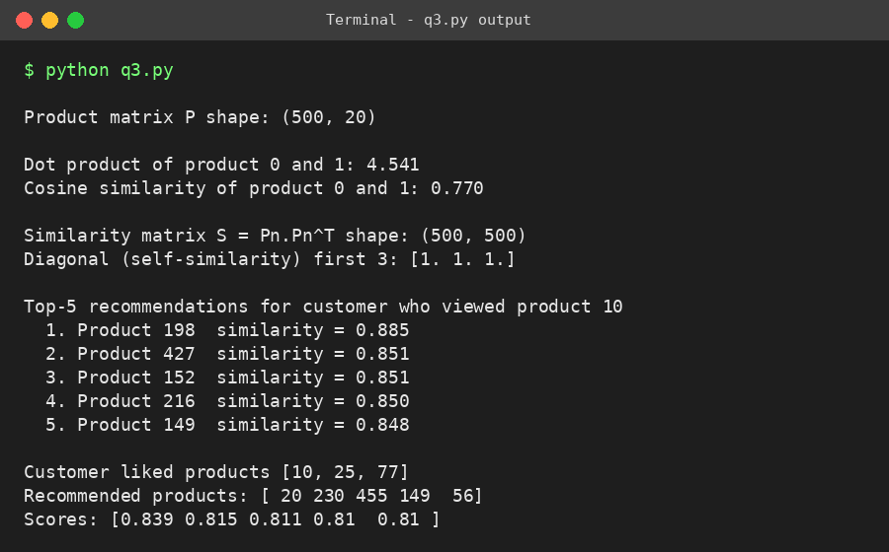
Fig. 3: Output screen of Program 3

Result
The 500 × 500 similarity matrix was obtained with a single matrix multiplication; its diagonal is 1, as expected for self-similarity. Products 198, 427, 152, 216 and 149 were the top recommendations for a customer who viewed product 10, and a profile-based score recommended products 20, 230, 455, 149 and 56 for a customer who liked products 10, 25 and 77.

Experiment 4: Medical Image Diagnosis

Problem Statement
A deep learning model uses a matrix of extracted medical image features to classify images as normal or abnormal. During training the model updates its weights using matrix operations. Explain how element-wise multiplication, matrix multiplication and vector addition contribute to forward propagation.

Theory
Let X be the feature matrix (images × features). The network used here is 5 → 4 → 1, with a ReLU hidden layer and a sigmoid output.
Z₁ = X W₁ + b₁ A₁ = Z₁ ⊙ (Z₁ > 0)
Z₂ = A₁ W₂ + b₂ ŷ = σ(Z₂)
- Matrix multiplication (X W₁, A₁ W₂): combines all features of all images with the learned weights, producing the hidden-layer and output-layer scores in one step.
- Vector addition (+ b): the bias vector is added to every row, letting each neuron shift its activation threshold independently of the input.
- Element-wise multiplication (⊙): ReLU is applied by multiplying Z₁ with a 0/1 mask (Z₁ > 0), zeroing negative values and introducing non-linearity. Without it, stacked layers would collapse into a single linear map.
The output ŷ is the probability of the image being abnormal; ŷ > 0.5 is classified as abnormal, otherwise normal.
Training (weight update). The error is propagated backwards with the same operations. The output error is dZ₂ = (ŷ − y)/N, the gradients are dW₂ = A₁ᵀ dZ₂ and dW₁ = Xᵀ dZ₁ (matrix multiplication), and dZ₁ = (dZ₂ W₂ᵀ) ⊙ (Z₁ > 0) (element-wise multiplication). The weights are then updated by gradient descent:
W ← W − η · dW b ← b − η · db

Algorithm
- Generate 40 image feature vectors (5 features each) with normal/abnormal labels.
- Initialise W₁, b₁, W₂, b₂.
- Forward pass: Z₁ = XW₁ + b₁, A₁ = Z₁ ⊙ (Z₁ > 0), Z₂ = A₁W₂ + b₂, ŷ = σ(Z₂).
- Compute the cross-entropy loss and back-propagate the gradients.
- Update the weights and repeat for 500 epochs; report loss and accuracy.

Program
import numpy as np
np.set_printoptions(precision=3, suppress=True, linewidth=100)
np.random.seed(0)

# 40 images x 5 extracted features; label 0 = normal, 1 = abnormal
X = np.random.randn(40, 5)
true_w = np.array([1.5, -2.0, 1.0, 0.0, 0.5])
y = ((X @ true_w + 0.3*np.random.randn(40)) > 0).astype(float).reshape(-1, 1)

# Network: 5 -> 4 (ReLU) -> 1 (sigmoid)
W1 = np.random.randn(5, 4) * 0.5; b1 = np.zeros((1, 4))
W2 = np.random.randn(4, 1) * 0.5; b2 = np.zeros((1, 1))
sig = lambda t: 1 / (1 + np.exp(-t))

def forward(X):
Z1 = X @ W1 + b1 # matrix multiplication + vector (bias) addition
A1 = Z1 * (Z1 > 0) + 0.0 # element-wise multiplication (ReLU as mask)
Z2 = A1 @ W2 + b2
return Z1, A1, sig(Z2)

Z1, A1, out = forward(X)
print("X:", X.shape, " W1:", W1.shape, " Z1:", Z1.shape, " A1:", A1.shape, " out:", out.shape)
print("\nForward pass (first 3 images)")
print("Z1 = XW1 + b1:\n", Z1[:3])
print("A1 = Z1 * (Z1>0) [element-wise]:\n", A1[:3])
print("Output probability:", out[:3].ravel())

def loss(p): return float(-np.mean(y*np.log(p+1e-9) + (1-y)*np.log(1-p+1e-9)))
print("\nInitial loss: %.4f | accuracy: %.1f%%" % (loss(out), 100*np.mean((out > .5) == y)))

# Training: weights updated with matrix operations
lr = 0.1
for ep in range(1, 501):
Z1, A1, p = forward(X)
dZ2 = (p - y) / len(X)
dW2 = A1.T @ dZ2; db2 = dZ2.sum(0, keepdims=True)
dA1 = dZ2 @ W2.T
dZ1 = dA1 * (Z1 > 0) # element-wise multiplication
dW1 = X.T @ dZ1; db1 = dZ1.sum(0, keepdims=True)
W1 -= lr*dW1; b1 -= lr*db1; W2 -= lr*dW2; b2 -= lr*db2
if ep % 100 == 0:
print("Epoch %3d loss = %.4f" % (ep, loss(p)))

_, _, p = forward(X)
pred = (p > .5).astype(int)
print("\nFinal accuracy: %.1f%%" % (100*np.mean(pred == y)))
for i in range(3):
print("Image %d -> prob %.3f -> %s" % (i, p[i,0], "Abnormal" if pred[i,0] else "Normal"))

Output
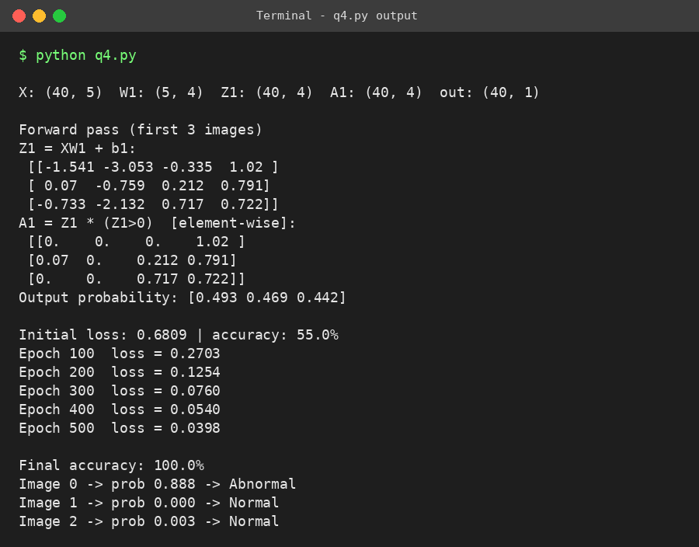
Fig. 4: Output screen of Program 4

Result
The forward pass used matrix multiplication for the weighted sums, bias addition for the offsets and element-wise multiplication for ReLU. Over 500 epochs of matrix-based weight updates, the loss fell from 0.6809 to 0.0398 and the training accuracy rose from 55% to 100%.

Conclusion
All four applications rely on the same small set of linear-algebra operations. Flattening converts an image into a vector, the dot product measures how well an input matches a weight pattern or another item, and matrix multiplication performs those dot products for every neuron or every sample at once. Adding the bias vector shifts each output, and element-wise multiplication supplies the non-linearity (ReLU) and gates the gradients during back-propagation. Expressing the computation in matrix form removes explicit loops, which makes it compact and efficient on modern hardware.

Summary of Operations
Operation | Where used | Role
Flattening | Experiment 1 | Turns an image matrix into an input vector
Dot product | Experiments 1, 3 | Weighted sum of one neuron; item similarity
Matrix multiplication | Experiments 1 to 4 | All neurons or all pairs computed together
Bias addition | Experiments 1, 2, 4 | Shifts each output; broadcast across rows
Element-wise (⊙) | Experiment 4 | ReLU activation and gradient masking

